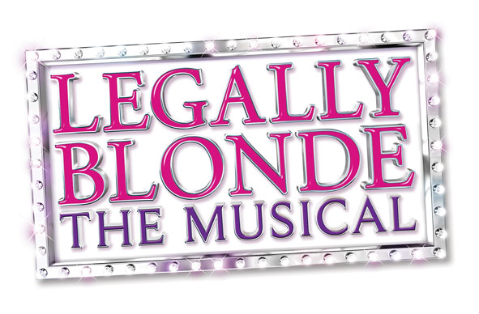
PRODUCTION PHOTO CREDITS

Photo 1: The cast of Legally Blonde – The Musical. Photo by Drager Creative.

Photo 2: Hannah Bonnett as Elle Woods in Legally Blonde – The Musical. Photo by Drager Creative.

Photo 3: Kaelee Albritton as Brooke and the cast of Legally Blonde – The Musical. Photo by Drager Creative.

Photo 4: The cast of Legally Blonde – The Musical. Photo by Drager Creative.

Photo 5: Ashley Morton as Paulette and Matthew Dean Hollis as Kyle in Legally Blonde – The Musical. Photo by Drager Creative.

Photo 6: The cast of Legally Blonde – The Musical. Photo by Drager Creative.

Photo 7: James Oblak as Warner and Hannah Bonnett as Elle Woods in Legally Blonde – The Musical. Photo by Drager Creative.

Photo 8: Hannah Bonnett as Elle Woods in Legally Blonde – The Musical. Photo by Drager Creative.

Photo 9: The cast of Legally Blonde – The Musical. Photo by Drager Creative.

Photo 10: Jesse Lynn Harte as Margot, Taylor Lloyd as Serena, and Rory Furey-King in Legally Blonde – The Musical. Photo by Drager Creative.

Photo 11: Aathaven Tharmarajah as Emmett and the cast of Legally Blonde – The Musical. Photo by Drager Creative.

Photo 12: Hannah Bonnett as Elle Woods and the cast of Legally Blonde – The Musical. Photo by Drager Creative.

